Use-Case Realization Report (Analysis)
Delete Question

Issue 1.0
Revision History
Date | Issue | Description | Author
01/Aug/09 | 1.0 | First Issue | Thomas Yap

Table of Contents
1. Brief Description 4
2. Flow of Events 4
2.1 Standard Flow 4
2.1.1 Delete Question 4
2.2 Exception 4
3. Interaction Diagrams 5
3.1 Collaboration Diagram for Delete Question 5
4. Participating Objects 5
5. Class Diagrams 6
5.1 Class Diagram for Delete Question 6
6. Derived Requirements 6

Use-Case Realization Report
Delete Question

Brief Description
This use case enables the controller to add new questions to Question Pool. It involves displaying the menu and form. It involves displaying the menu and form and search by searchstrings or list to delete the record.

Flow of Events
The standard flow of events for this use case and any exceptions are described in the following subsections. The events are described in terms of Actors and Analysis Objects.

Standard Flow
This use case covers the Question Maintenance - Delete Question. The standard flow of these events are described below.

Delete Question
The running of the application is shown in section 3.1. The flow of event is as follow:

- When the application start, the first operation to be performed is the startup operation of the main controller. This operation will create all the control objects and the entity objects necessary for operation Delete Question:
  - The control object created is: Question Controller
  - The entity objects create are: Question and Transaction Record

- The main controller will start the main function menu:
  - To start Delete Question, operation FormDisplayQuestion is activated by Question Controller to display a Question form.
  - Use Case Display Question List will retrieve a title list of Question for Portal Admin to pick to be display on FormDisplayQuestion.
  - Operation validate will validate the format of the entries.
  - Then Question Controller will check for additional criteria if any.
  - If no record found, Question Controller will send a error message to FormDisplayQuestion Interface.
  - After the record is found and display on FormDisplayQuestion, a confirmation request will be sent to the FormDisplayQuestion interface. Upon confirmation, the record will then be deleted from file using operation delete to entity object Question.
  - In addition, a transaction log will be created by operation createRecord
  - The request can be cancelled and no data will be altered. In this case, a transaction record will still be created for traceability.
  - A confirmation message will be displayed by FormDisplayQuestion interface.

- Step 2 will be repeated until all deletions are completion. Then controller will terminate the application by issuing operation close.

Exception
None.

Interaction Diagrams

Collaboration Diagram for Delete Question
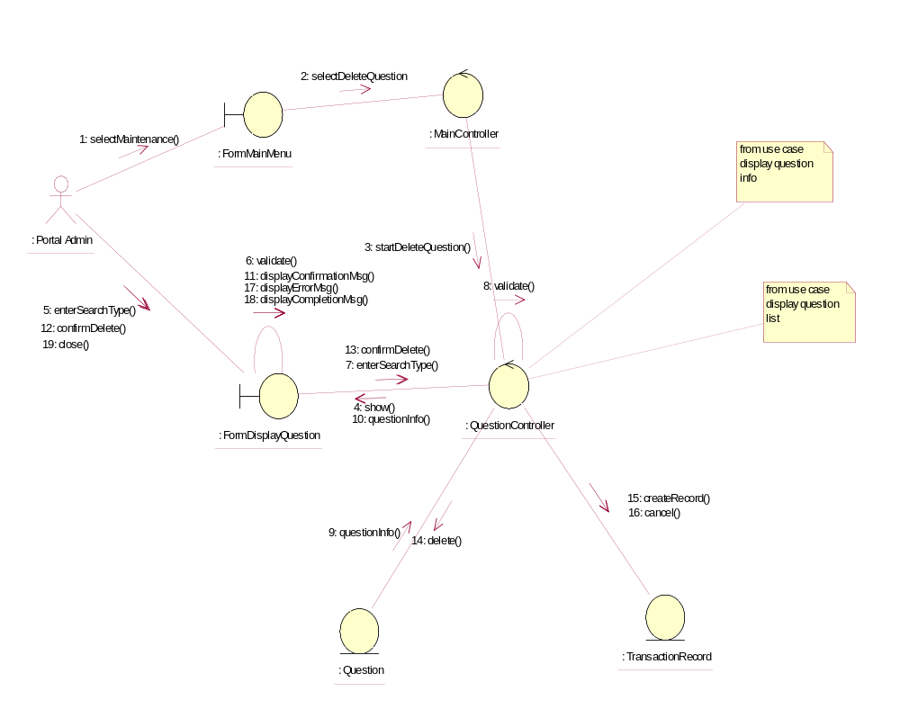

Participating Objects
: FormDisplayQuestion
This object is the interface for keying questions details.

: FormMainMenu
This is the main menu at the beginning of the application from where it can access the Question Maintenance - Delete Question operation.

: MainController
This is the main controller that control the whole system.

: Portal Admin
This is the only actor that authorized to perform operation Question Maintenance - Delete Question.

: Question
This entity stores all the exam or exercise questions.

: QuestionController
This is the controller for Question Maintenance. It creates and activates FormDisplayQuestion interface and Question entity object.

: TransactionRecord
This is the entity object that created for transaction log and audit trail.

Class Diagrams

Class Diagram for Delete Question
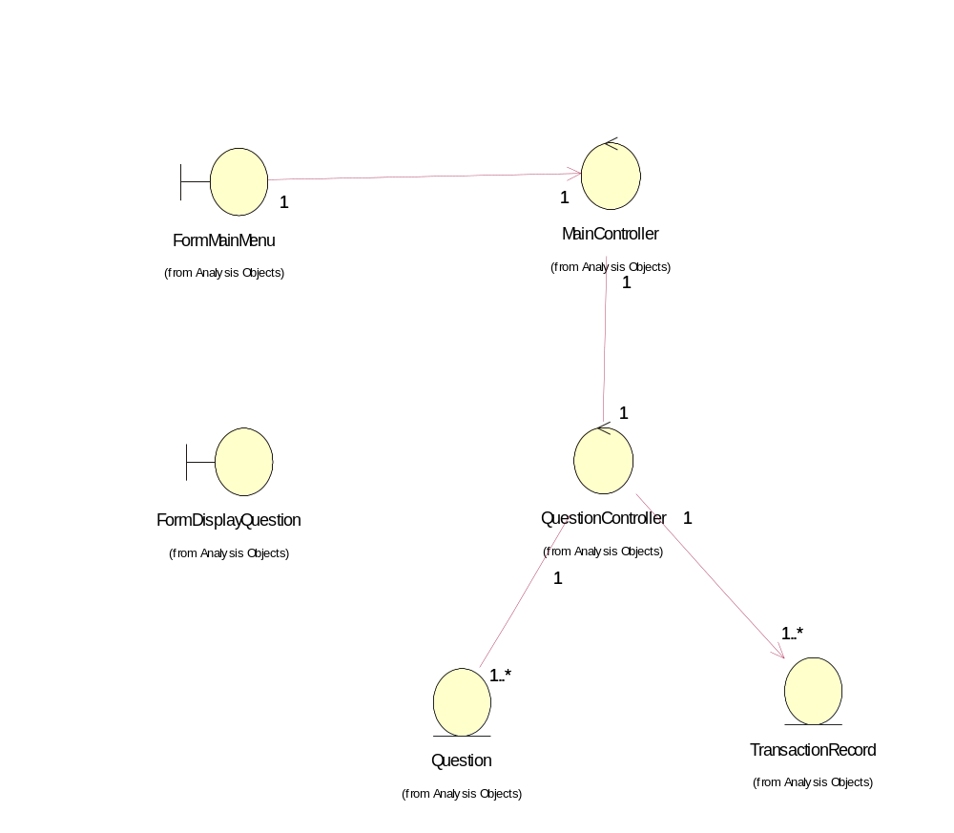

Derived Requirements
The FormMainMenu and FormDisplayQuestion Interface should have the format specified in User Requirements Specification for Content Management Portal.

